**Accessing the Forecourt Device Controller (FDC) from a PC within the station network**

1. Connect to the station PC via RustDesk
2. Go to any browser (Chrome, Edge or Firefox) and search fdc

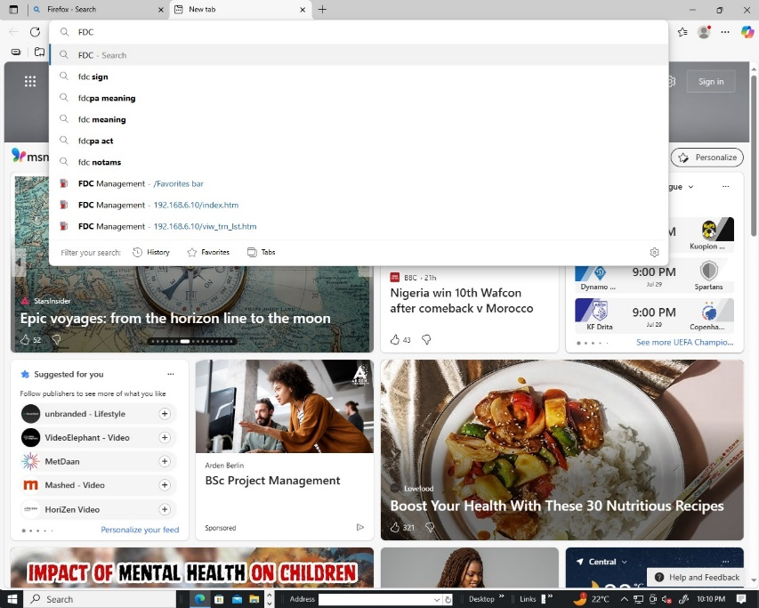

1. A frequently searched fdc statement should pop up >> If not, follow the following steps:

* Go to the Wi-Fi on the station pc and make sure it is connected to the Automation Wi-Fi.

**NB:** This only happens with Ugandan stations

* Go back to the browser search and type fdc

1. If the above methods fail to work and you fail to connect to the fdc, type in the following IP on the web browser search 192.168.5.10
2. After searching fdc and clicking the link, a pop up will appear
3. For an Admin signing in, enter:

* User name- rohe
* Password- 701106

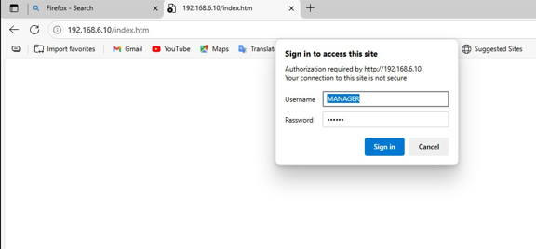

**NB:** Remember tolog out of the fdc session to prevent the station managers from tampering with the extra admin settings

1. For a station manager signing in, enter:

* User name- MANAGER
* Password- 123456

1. After signing in, the fdc looks different depending on whether an Admin or Manager signed in. Navigate to the left and scroll down the settings.

* Admin view

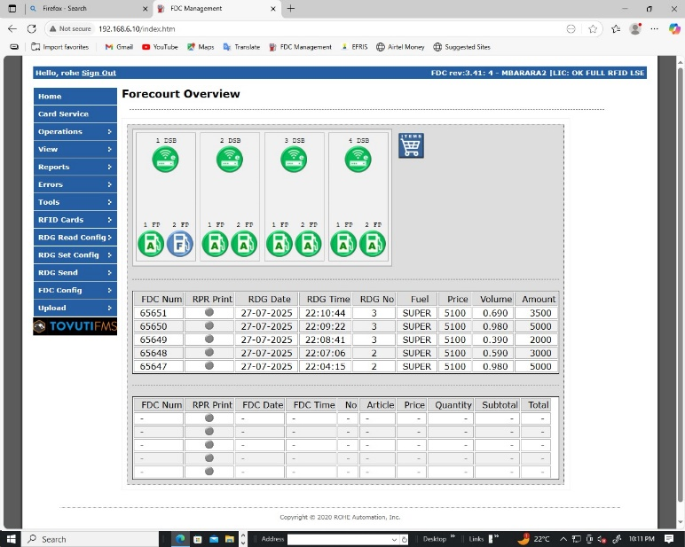

* Manager view

